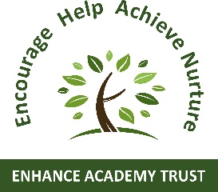

LEPTON CE PRIMARY ACADEMY SAFE SUN POLICY

Aims
- To present information to parents and children about enjoying the sun safely.
- To encourage and inform our children of sun safe behaviour at school and teaching about the risks of sunlight.
- To incorporate the knowledge of sun care in to other curriculum areas and discussion opportunities.
- To make the children aware of areas within our school environment which provide shade.
- To make children aware of the dangers of the sun and how to protect themselves against these when in other settings away from school, eg. Visits out and residential visits.

Introduction
Sunshine makes the world a pleasant place to live and we all want to be outside enjoying sunny weather. We also must recognise that dangers from the sun can happen on cloudy days too.
The U.V. rays from the sun can be harmful, particularly to young children’s skin and eyes. The heat from the sun can also cause dehydration and sun stroke.

Guidance
Always be prepared for the likelihood of the sun’s rays causing harm.
To prevent this:
- Wear suitable clothes, covering up most of the skin, particularly shoulders and neck.
- Wear hats which cover the head and neck. (these can be brought into school to wear during playtimes and during PE sessions).
- Parents are encouraged to apply high protection sun cream, preferable no lower than SPF 25 before school. This will last all day as long as the child does not wash it off.
(Sun cream must not be administered by staff.) In the event of children being on a residential visit, parents are encouraged to teach their children how to apply sun cream to themselves, children are then reminded to do this during the visit.
- Children are encouraged to drink plenty of fluids, preferably water, which is always available in school.
- When very hot, teachers are advised to take regular short breaks throughout the day rather than keep children outside for prolonged periods eg the whole of playtime or lunchtime.
- Children are encouraged to seek shady places to sit if the sun is very bright and hot.
- Teachers should take great care when keeping children outside for prolonged PE activities when the sun is very bright and hot. Lessons may be shortened or combined with periods in the school hall.
- Staff must also be mindful of long-term exposure when taking children offsite as this should be considered as part of the risk assessment prior to the visit taking place.
For safeguarding reasons staff are not permitted to apply sun screen on children.

