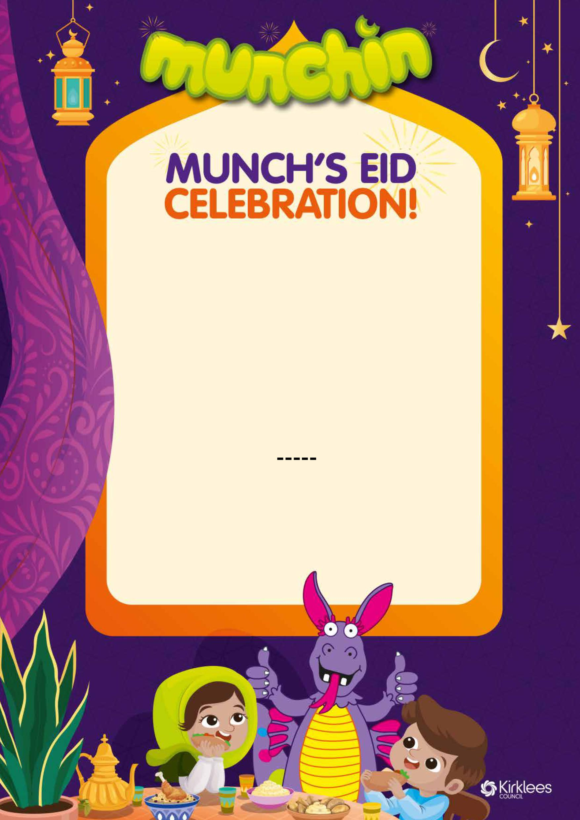
Traditional Menu
Authentic Chicken Curry
or
Vegetable Korma
All the above are served with rice,
naan bread, mini samosa and riata
Jacket Potato with Beans and Cheese
Dessert
Eid Biscuit
Chocolate Slab Cake
Fresh Fruit

