Contact us on the following number:

Single Point of Contact Telephone:
Reception Screening Leaflet

0300 304 5555


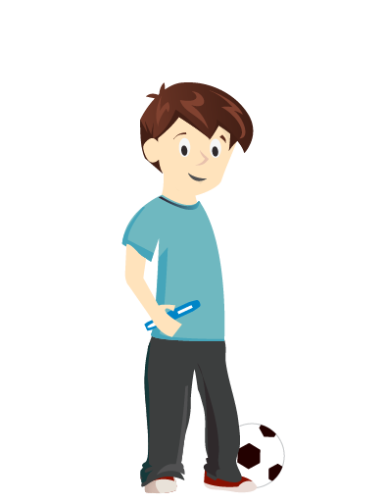
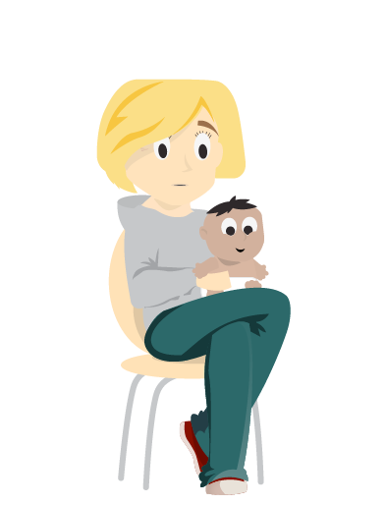

www.facebook.com/LocalaCommunityPartnerships

@Localahealth



Primary Health Screening

Locala Community Partnerships
Freepost plus RSTJ-EYJA-UCTB
Beckside Court, Bradford Road, Batley WF17 5PW
Customer Liaison: 030 3003 4529 or enquiry@locala.org.uk
www.locala.org.uk
This leaflet is available in other languages and can be made available in large print, Braille or on audiotape
Ref: CL1010 Date of publication: August 2018

Contents
Overview of the Locala 0-19 Service
The screening process
Screening results and outcomes(helpful information)
Bedwetting helpful tips
Head lice
Behaviour

Date

……………………………………………………

Weight

……………………………………………………

Height

……………………………………………………

Vision

……………………………………………………

Hearing

……………………………………………………

The Service

“All children, young people and families living in Kirklees will thrive, be healthy and resilient, drawing on individual and community assets to achieve the best outcomes”

Every school aged child in Kirklees has access to the Locala 0-19 service and we can offer advice, support and care on health and wellbeing issues.

Recommendations of the Service

Your child should be registered with a GP (Doctor). If not, please contact your local surgery to register.
- We recommend all childhood immunisations are up to date – please contact your GP for this information.
- Your child should be registered with and visiting a dentist regularly. If not, please visit the NHS Choices website and search for local practices with NHS child places.
- The 0-19 Service recommend that parents/ carers take their children to the optician from an early age.

Our Services

The Screening Process | The 0-19 Service provides  - Health advice and support to schools, children and young people and their parents/carer.  - Undertakes school entry health assessment, which includes screening  - Makes referrals to specialist services.  - Supports children and families with special needs and complex medical needs.  Children are seen in school during the reception year for a growth assessment and vision test. If there is a potential concern, then hearing may also be tested. You are asked to complete a health questionnaire to highlight any concerns you may have about your child. Please visit https://www.thrivingkirklees.org.uk/school-health-self-assessment/ where you can carry out a simple self assessment and refer to the 0-19 team for extra support should you and your child require.  Health visitors and school are also asked to inform us of any concerns they may have, this helps the 0-19 service offer the appropriate advice and support.

Helpful Information

What happens if a problem is found?

Hearing  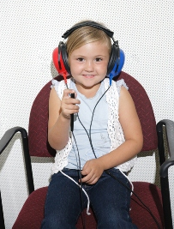 | When your child has been seen in school you will receive a feedback letter, this will inform you of the outcome. The results may suggest a referral on to other services or a recall which will take place in school.  Hearing (if screening is required) - results may suggest a re-test, if a child has a cold their hearing can be affected. Some results suggest a referral to the audiology clinic and an appointment will be sent in the post from the audiology department.
  

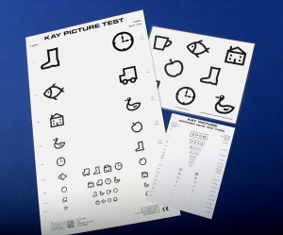
Vision
Vision - you may be asked to take your child to the optician or referral to the orthoptist may be required.
Conditions such as squints and unequal vision require detection and treatment before the age of 7.

Praise

As an aid to changing behaviour, praise plays an important role. It gives your child the attention they want, but only for being well behaved.
Praising must be used in conjunction with ignoring. It is very important to always notice when your child is behaving well.
On some days it might be difficult to find something to praise about your child, but do try to comment positively on something however small every day.

Routine

Children like routine, it makes them feel safe and secure e.g. bedtime, mealtimes. Be clear about what you expect from your child and what they can expect from you.
- Always stick to what you say
- Structure and routine help children control their behaviour
- Children need to understand the consequences of not doing what you ask
Do not make threats to your children and then change your mind. This undermines your authority and encourage your child to keep testing you.

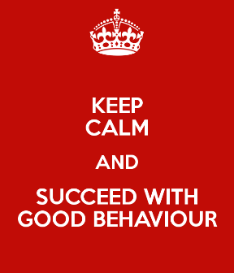

Behaviour

You may find your child’s behaviour challenging at times. There are four techniques you may find useful:-

Stay calm

If you shout at your child when he/she misbehaves, you are actually giving your child lots of attention for being naughty.
Shouting also gives your child the message that you have lost control.
This can make your child feel emotionally powerful and will try to do this again.
Try to stay calm when your child misbehaves and keep control of the situation.

- Practice staying calm
- Try not to shout
- Take deep breaths
- Think about something pleasant

Ignore

Ignoring misbehaviour takes lots of practice, but it is one of the most effective ways to change behaviour. Children do not like being ignored.
Use ignoring if your child does not respond to being told verbally to stop (only tell him/her twice).
Ignoring means not speaking to or looking at your child when they are misbehaving.
Removing yourself from the situation is also a way of ignoring, e.g. move into another room.

Growth

Childs growth chart  Speech  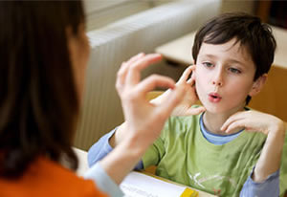 | Your child’s height and weight will be measured and results plotted on a growth chart. Children may be recalled and measured again if they are plotted outside the normal range i.e. tall/small for their age.  A referral may be made to GP’s, or you will be offered support to help your child achieve a healthy weight if their weight is outside the normal range.  The 0-19 Service supports healthy eating and exercise and are happy to offer advice.  If you have any issues around your child’s speech or level of understanding, you are able to self-refer to the speech and language services or ask school staff for support with a referral.
  

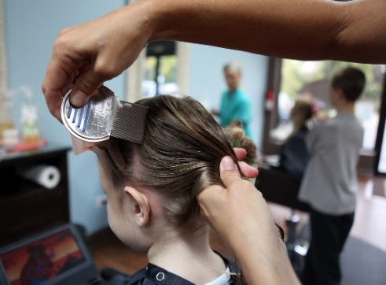

Head Lice

Head lice are very common and live on the hair, feeding on the scalp by sucking blood. They are easily passed from one child to another due to the way children play in close contact. Don’t worry as this can be treated.
Adults and children can get head lice, always check the whole family.

Head lice walk from head to head they cannot fly or jump.
How to spot lice

Dampen hair thoroughly and apply conditioner. Make sure there is good lighting, brush then comb hair through. Using a head lice detection comb begin at the top of the head with comb touching the scalp, comb slowly to the end of the hair onto a white piece of paper, and check the comb, repeat, working around the head. (Wet combing)
What to do if head lice are found
Lotion can be bought from the chemist and applied as instructed. Ask the chemist for advice.
Use the detection comb regularly to stop re infection.

Bedwetting

Bed wetting (nocturnal enuresis) is a common childhood problem and in most cases resolves itself over time. If your child has pain or difficulty in passing urine contact the GP.

What can you do to help
- Encourage your child to drink plenty of water during the day. This helps to increase bladder capacity and hydrates your child during the day rather than taking all fluids in the evening.
- Be careful with fizzy drinks and drinks which contain caffeine (tea, coffee, chocolate) as these increase the production of urine.
- Encourage a healthy diet, fruit, vegetables, and cereal to avoid constipation.
- Ensure your child goes to the toilet twice before bed, i.e. before and after story time.
- To avoid stale smell of urine, make sure they shower or bath in the morning.
- Stay calm, remember bed wetting is not their fault, and give plenty of encouragement, love and patience.
- Make sure your child does not wear nappies to bed as this can delay becoming dry.
If you would like more support for bed wetting contact the service.

