Locala 0 - 19 Services
Batley Health Centre
130 Upper Commercial Street
Batley
WF17 5ED
www.Locala.org.uk
Tel: Single Point of Contact (SPOC)
030 0304 5555
Academic Year 2025/26

Dear Parent or Guardian

We are writing to inform you that your child will be weighed and measured by the Locala 0-19 Team at school in the next few weeks as part of the National Child Measurement Programme.

Height and weight checks for children in Year 6

Every year in England, school children in reception and year 6 have their height and weight checked at school. This is called the National Child Measurement Programme (NCMP). The checks are carried out by registered school nurses or trained health and care providers. Children are measured fully clothed, except for their coats and shoes, in a private space away from other pupils.

Why do we need to measure children?
Children’s height and weight measurements are collected to build an understanding of how children are growing. The information from the NCMP is used by local councils and the NHS to plan the provision of health and leisure services for families to promote healthier growth in children.
In most areas, parents receive their child’s measurement data, because this can be useful information about their child’s growth. Your child’s class will take part in this year’s programme.
What information is collected and why

Your child’s height, weight, age, sex, and date of birth are collected to calculate their weight category (also known as child body mass index).

Your child’s ethnicity and address are collected to monitor differences in child growth and weight between ethnic groups, where children live and their backgrounds.

Your child’s name, date of birth and NHS number are collected to link their measurements from reception and year 6 to other information from health and education records held by NHS England, the Department of Health and Social Care and the Department for Education, where it is legal to do so.

Information about how personal information and data is collected and stored
You can read more about how the Department of Health and Social Care collects, stores and uses your child’s information and data in the National Child Measurement Programme privacy notice.
You can read more about how NHS England collects, stores and uses your child’s information and data at National Child Measurement Programme (NCMP): GDPR information.
At the NHS England National Child Measurement Programme webpage you can read more about:
- taking part in the programme
- how your data is collected
- how your data is used

We will store your child’s information as part of their local child health record on the NHS’s child health information database and share it with their GP.
All the information collected about your child will be sent by us to NHS England. NHS England is responsible for collecting data and information about health and care so that this can be used to monitor and improve the care provided to people across England.
Kirklees Council commission Locala to deliver the NCMP locally. You can read more about how Locala collects, stores and uses your child’s information at the following link Locala Privacy Notice
Kirklees Council’s Public Health Team access, download and verify information collected by Locala via the NCMP IT system provided by NHS England for example school level data, which helps to inform provision of local services. You can read more about how Kirklees Council collects, stores and uses information and data at the following link Kirklees Council Privacy Notice for National Child Measurement Programme.

How you can withdraw your child from participating in the NCMP

If you are happy for your child to be measured, the check will go ahead in school and you do not need to do anything.

If you do not want your child’s height and weight to be measured, or your child has a medical condition that affects their height or weight please inform your child’s school in writing within 7 days of receiving this letter.

Children will not be made to participate if they do not want to.

Parents/carers will receive an SMS text message containing a webpage link to your child’s weight category.

Please contact the Locala 0-19 service on 030 0304 5555 if you do not receive your child’s result within 8 weeks of being measured.

Further information can be found here locala.org.uk/services/health-visiting/ncmp

How is a child’s wellbeing considered in the NCMP

The wellbeing of children and families is very important. Measurements are conducted in a sensitive way, in private and away from other children. Individual feedback is not shared with your child or their school.

The weight and height information is shared only with you via SMS and web link. It is your choice to share or not share the information with your child. There are some useful resources to help you make these decisions here: https://www.nhs.uk/healthier-families/childrens-weight

If you are concerned about your child’s growth, weight, body image or eating patterns, seek further support from a school nurse or family GP.

Further information

Visit our website locala.org.uk/services/health-visiting/ncmp for further information about NCMP in Kirklees.

Further information about the National Child Measurement Programme can be found at https://www.nhs.uk/live-well/healthy-weight/national-child-measurement-programme

Information and fun ideas to help your kids stay healthy can be found at
https://www.nhs.uk/healthier-families/

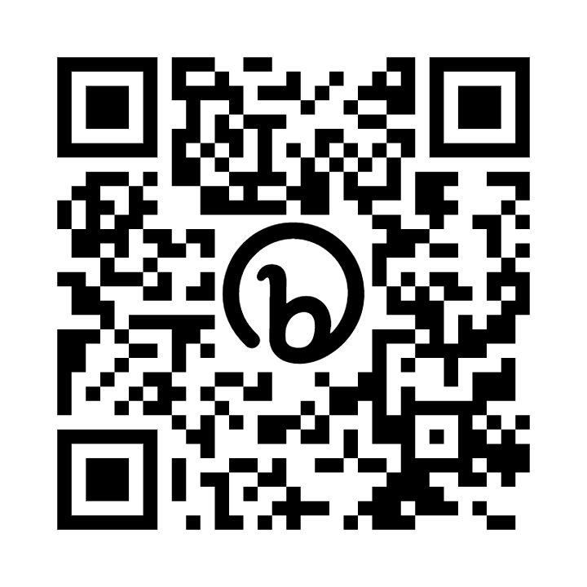
Another way to help maintain a balanced diet and physical activity for your family is the NHS Healthy Steps email programme. Sign up for the 8-week Healthy Steps emails and you will be sent lots of low-cost easy tips, fun games, healthy swaps and tasty recipes on a budget. Scan the QR code, or visit Healthy Steps - step this way to sign up.

Yours faithfully,
Melanie Giles
Melanie Giles
Locala 0-19 Team Leader

