Here’s your child’s opportunity to practice cycling on quiet roads with trained instructors.
Places will be confirmed on a first come basis.

WHAT IS BIKEABILITY? Bikeability is the national cycle training programme supported and funded in part by the Department for Transport. The 2-day course builds the skills and confidence of children who can already ride. Bikeability makes children better cyclists and helps with general confidence and independent thinking.
Bikeability training is delivered by qualified, professional, DBS-checked National Standard Instructors.
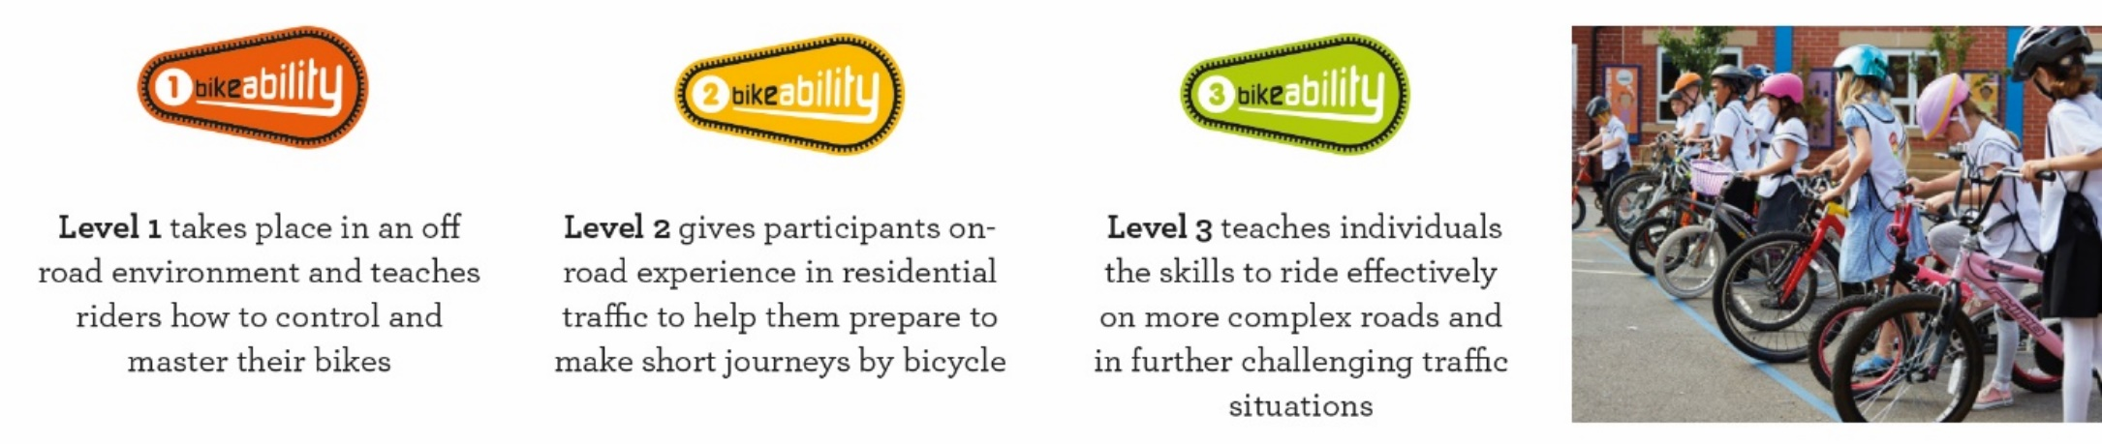 | Level 1 takes place for half a day in the playground. Riders practice the skills they will need to ride on the road. Riders with these skills will move on to Level 2.  Level 2 gives riders 1 ½ days on-road experience riding in traffic to help them to make short journeys by bike. They will learn the rules of the road that all road users adhere to.
COURSE DATE(S)(S) | BIKEABILITY LEVEL 1-2 - 18 PLACES for Y6  BK1 – TUE 3-WED 4 JUNE 2025 | 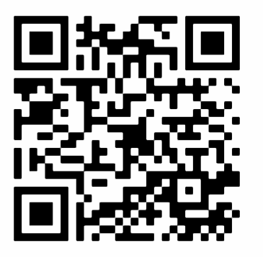 | Please confirm no later than TUE 20 MAY 2025
YOUR CHILD WILL NEED… | - A ROADWORTHY BIKE. Tyres must be pumped up and both brakes work. BMX bikes must have two working brakes.  - A CYCLE HELMET. NO BMX full face helmets are allowed as they make it difficult to see and hear traffic.  - Suitable clothing for the weather conditions. Earrings must not be worn during the course.  - Bikes and helmets are available to borrow from school if needed. Please speak to the school about availability, but if your child has a bike it is better if they bring it as they will be more used to it.
Book your child’s place using the URL link below or by scanning the QR Code above:
URL: https://consent.bikeability.org.uk/pam-guess-stay
If you are unable to use the URL or QR Code please ask the school for a paper booking form.
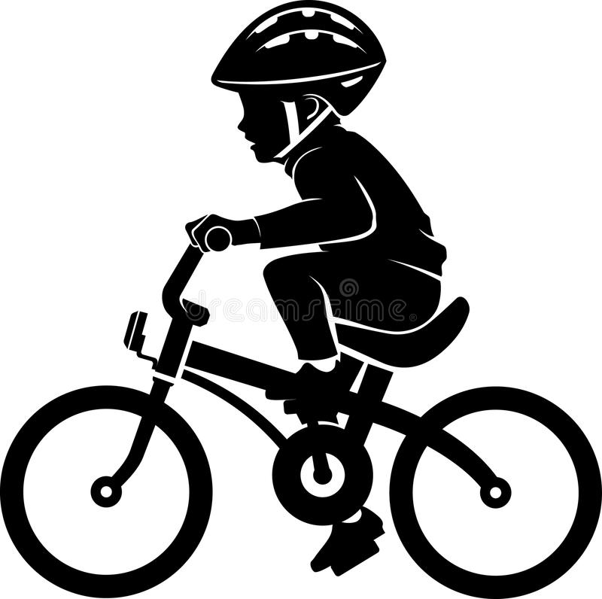
BEFORE THE COURSE, PLEASE CHECK THE FOLLOWING…
HELMET
- The helmet should fit flat on the head, to protect your child’s forehead.
- Long hair should be tied back at the neck so that the helmet fits properly.
- The straps at either side should fit snugly and the buckles at the bottom of the ‘v’ shape (if it has them) should fit under each ear.
- Make sure that you can get no more than a couple of fingers between the strap and your child’s chin.
BIKE
- Pump up both tyres so that they are as hard as an apple. Please note BOTH BRAKES MUST WORK.
- Oil the chain if it looks a bit rusty. This will make pedalling easier.

I understand that:
- The instructors may refuse to train my child if they deem their bike to be unroadworthy. It remains my responsibility to ensure my child’s bike is roadworthy. If I am in any doubt, I should seek the advice of a professional mechanic.
- Instructors may at any time refuse to continue to train my child if their behaviour or cycling ability is deemed unsuitable.
- Ask for the Moon Ltd is not responsible for any injury or liable for any loss or damage to participant’s bike / belongings.
- Bikeability instructors may need to adjust your child’s helmet. They are not responsible for the physical condition or appropriate fitting of the helmet.
- Pupil data will be collected and used to support the delivery and monitoring of training sessions / courses.
See bikeability.org.uk/privacy-statement/ for further details.

